# OKS – CV 5

Peter Hadač

Pavol Tuka

## 0.Topológia

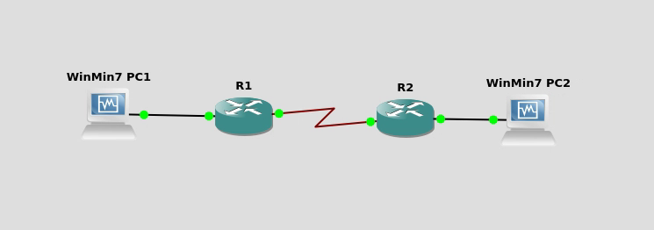

## 1. Preskúmajte hardvérový front smerovača

* Zmeňte rýchlosť sériovej linky a odsledujte či a ako sa zmení HW front TxRing pre dané rozhranie - konkrétne sledujeme jeho veľkosť (môže robiť každý na svojom smerovači na výstupnom rozhraní):

Pôvodný výpis:

M4T: show controller:

PAS unit 0, subunit 0, f/w version 3-101, rev ID 0x2800001, version 1

idb = 0x668FF284, ds = 0x66900494, ssb=0x66900860

Clock mux=0x0, ucmd_ctrl=0x1C, port_status=0x7B

Serial config=0x8, line config=0x200

maxdgram=1608, bufpool=48Kb, 96 particles

DCD=up DSR=up DTR=up RTS=up CTS=up

line state: up

cable type : V.11 (X.21) DCE cable, received clockrate 128000

base0 registers=0x3C800000, base1 registers=0x3C802000

mxt_ds=0x67A4E514, rx ring entries=47, tx ring entries=63

rxring=0xE21B940, rxr shadow=0x66907274, rx_head=39

txring=0xE21BB00, txr shadow=0x669074E8, tx_head=42, tx_tail=42, tx_count=0

throttled=0, enabled=0

halted=0, last halt reason=0

Microcode fatal errors=0

rx_no_eop_err=0, rx_no_stp_err=0, rx_no_eop_stp_err=0

rx_no_buf=0, rx_soft_overrun_err=0, dump_err= 0, bogus=0, mxt_flags=0xC

tx_underrun_err=0, tx_soft_underrun_err=0, tx_limited=1(2)

tx_fullring=213373, tx_started=5991, mxt_flush_count=0

rx_int_count=1078, tx_int_count=219365

Half-duplex hdx=0x66906F80, summary:-

invalid_state=0, jigged_sig=0, invalid_timeout=0, tx_drop=0

tx_int_err=0, rx_drop=0, timer_error=0, rts_timeout=0

invalid_rx=0, tx_lost_cts=0, cts_timeout=0, late_rx=0

Zmena Rýchlosti - Neudialo sa nič

Sender(config-if)#band 256

Sender(config-if)#do show controllers s1/0

M4T: show controller:

PAS unit 0, subunit 0, f/w version 3-101, rev ID 0x2800001, version 1

idb = 0x668FF284, ds = 0x66900494, ssb=0x66900860

Clock mux=0x0, ucmd_ctrl=0x1C, port_status=0x7B

Serial config=0x8, line config=0x200

maxdgram=1608, bufpool=48Kb, 96 particles

DCD=up DSR=up DTR=up RTS=up CTS=up

line state: up

cable type : V.11 (X.21) DCE cable, received clockrate 128000

base0 registers=0x3C800000, base1 registers=0x3C802000

mxt_ds=0x67A4E514, rx ring entries=47, tx ring entries=63

rxring=0xE21B940, rxr shadow=0x66907274, rx_head=41

txring=0xE21BB00, txr shadow=0x669074E8, tx_head=44, tx_tail=44, tx_count=0

throttled=0, enabled=0

halted=0, last halt reason=0

Microcode fatal errors=0

rx_no_eop_err=0, rx_no_stp_err=0, rx_no_eop_stp_err=0

rx_no_buf=0, rx_soft_overrun_err=0, dump_err= 0, bogus=0, mxt_flags=0xC

tx_underrun_err=0, tx_soft_underrun_err=0, tx_limited=1(2)

tx_fullring=213373, tx_started=5993, mxt_flush_count=0

rx_int_count=1080, tx_int_count=219367

Half-duplex hdx=0x66906F80, summary:-

invalid_state=0, jigged_sig=0, invalid_timeout=0, tx_drop=0

tx_int_err=0, rx_drop=0, timer_error=0, rts_timeout=0

invalid_rx=0, tx_lost_cts=0, cts_timeout=0, late_rx=0

Zmena tx-ring-limitu:

Sender(config-if)#tx-ring-limit 10

M4T: show controller:

PAS unit 0, subunit 0, f/w version 3-101, rev ID 0x2800001, version 1

idb = 0x668FF284, ds = 0x66900494, ssb=0x66900860

Clock mux=0x0, ucmd_ctrl=0x1C, port_status=0x7B

Serial config=0x8, line config=0x200

maxdgram=1608, bufpool=48Kb, 96 particles

DCD=up DSR=up DTR=up RTS=up CTS=up

line state: up

cable type : V.11 (X.21) DCE cable, received clockrate 128000

base0 registers=0x3C800000, base1 registers=0x3C802000

mxt_ds=0x67A4E514, rx ring entries=47, tx ring entries=63

rxring=0xE21B940, rxr shadow=0x66907274, rx_head=7

txring=0xE21BB00, txr shadow=0x669074E8, tx_head=7, tx_tail=7, tx_count=0

throttled=0, enabled=0

halted=0, last halt reason=0

Microcode fatal errors=0

rx_no_eop_err=0, rx_no_stp_err=0, rx_no_eop_stp_err=0

rx_no_buf=0, rx_soft_overrun_err=0, dump_err= 0, bogus=0, mxt_flags=0xC

tx_underrun_err=0, tx_soft_underrun_err=0, tx_limited=1(10)

tx_fullring=213373, tx_started=6035, mxt_flush_count=0

rx_int_count=1122, tx_int_count=219410

Half-duplex hdx=0x66906F80, summary:-

invalid_state=0, jigged_sig=0, invalid_timeout=0, tx_drop=0

tx_int_err=0, rx_drop=0, timer_error=0, rts_timeout=0

invalid_rx=0, tx_lost_cts=0, cts_timeout=0, late_rx=0

Zmenu avšak vidno len v RUNNING-CONFIG

Sender(config-if)#do sh run partition int s1/0

Building configuration...

Current configuration : 168 bytes

!

Configuration of Partition - interface Serial1/0

!

!

!

interface Serial1/0

ip address 10.0.12.1 255.255.255.0

tx-ring-limit 25

bandwidth 128

Clock rate 128000

!

!

End

## 2. Preskúmajte defaultné nastavenia WFQ

* a. Zapnite WFQ (na novších mserovačoch sa to realizuje iba cez policy map, na starších na rozhraní) na sériovom rozhraní a nastavte kapacitu linky na 128kbps

policy-map wfq

class class-default

fair-queue

* b. Zistite (show interface s0/0..) aké sú hodnoty pre:
  + i. CDT (congestive discard threshhold)
  + ii. Hold-queue
  + iii. Max. počet front ktoré automaticky vytvára a indexuje do nich prichádzajúe pakety (Conversations...)

Serial1/0 is up, line protocol is up

Hardware is M4T

Internet address is 10.0.12.1/24

MTU 1500 bytes, BW 128 Kbit/sec, DLY 20000 usec,

reliability 255/255, txload 1/255, rxload 1/255

Encapsulation HDLC, crc 16, loopback not set

Keepalive set (10 sec)

Restart-Delay is 0 secs

Last input 00:00:03, output 00:00:06, output hang never

Last clearing of "show interface" counters never

Input queue: 0/75/0/0 (size/max/drops/flushes); Total output drops: 167350

Queueing strategy: weighted fair

Output queue: 0/1000/64/167350 (size/max total/threshold/drops)

Conversations 0/5/256 (active/max active/max total)

Reserved Conversations 0/0 (allocated/max allocated)

Available Bandwidth 96 kilobits/sec

5 minute input rate 0 bits/sec, 0 packets/sec

5 minute output rate 0 bits/sec, 0 packets/sec

933 packets input, 99513 bytes, 0 no buffer

Received 687 broadcasts (0 IP multicasts)

0 runts, 0 giants, 0 throttles

0 input errors, 0 CRC, 0 frame, 0 overrun, 0 ignored, 0 abort

4227 packets output, 1908038 bytes, 0 underruns

0 output errors, 0 collisions, 5 interface resets

0 unknown protocol drops

0 output buffer failures, 0 output buffers swapped out

8 carrier transitions DCD=up DSR=up DTR=up RTS=up CTS=up

* d. Pokúste sa zmeniť jednotlivé hodnoty pre hold-queue aj max. počet front

Pracovali sme na IOS 15.2 .

## 3. Experimenty s FIFO, PQ a WFQ

* ii. Zaznamenávajte straty a oneskorenia cez D-ITG (logger)
* iii. FIFO, PQ a WFQ sú dostupné aj na novších IOSoch, CQ už nie (preto na novších IOSoch sa CQ nepokúšať testovať, iba ostatné tri)
* iv. Návod je robený pre staršie IOSy, preto si vždy overte funkčnosť na vašom IOSe - možné zdroje:

### FIFO

Fifo vs. IOS 15.2

Nevedel som ako zmeniť z Default WFQ na FIFO

Configuring CBWFQ on a physical interface is only possible if the interface is in the default queueing mode. Serial interfaces at E1 (2.048 Mbps) and below use WFQ by default--other interfaces use FIFO by default. Enabling CBWFQ on a physical interface overrides the default interface queueing method. Enabling CBWFQ on an ATM permanent virtual circuit (PVC) does not override the default queueing method.

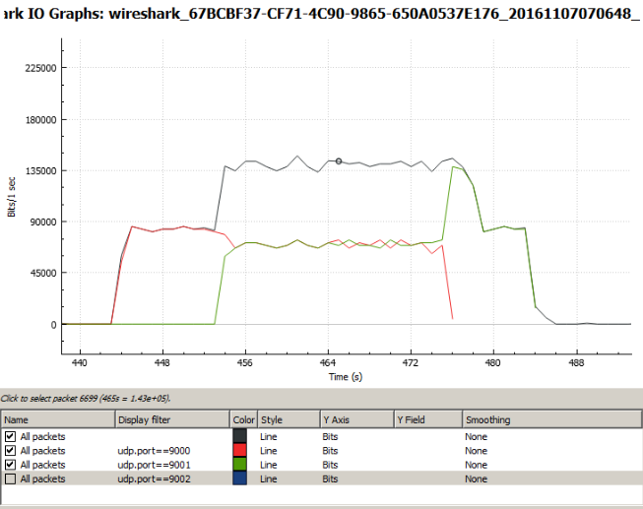

**************** TOTAL RESULTS ******************

Number of flows = 3

Total time = 46.244000 s

Total packets = 700

Minimum delay = 0.045000 s

Maximum delay = 10.201000 s

Average delay = 2.076366 s

Average jitter = 0.228767 s

Delay standard deviation = 3.791089 s

Bytes received = 358400

Average bitrate = 62.001557 Kbit/s

Average packet rate = 15.137099 pkt/s

Packets dropped = 25621 (97.34 %)

Average loss-burst size = 483.415094 pktError lines = 0

----------------------------------------------------------

### PQ

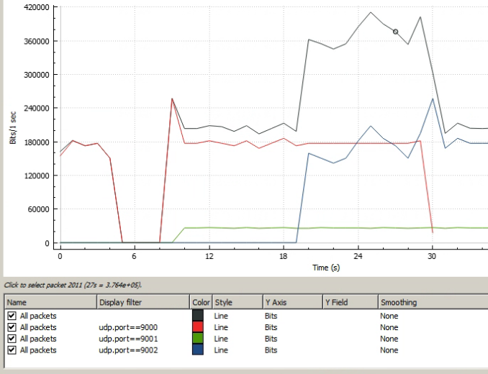

**************** TOTAL RESULTS ******************

Number of flows = 2

Total time = 40.705000 s

Total packets = 750

Minimum delay = 0.063000 s

Maximum delay = 9.286000 s

Average delay = 1.393740 s

Average jitter = 0.096131 s

Delay standard deviation = 2.478303 s

Bytes received = 384000

Average bitrate = 75.469844 Kbit/s

Average packet rate = 18.425255 pkt/s

Packets dropped = 20817 (96.52 %)

Average loss-burst size = 36.266551 pkt

Error lines = 0

----------------------------------------------------------

### WFQ

Pri WFQ I/O graf vyzeral nasledovne:

